|  |  |
| --- | --- |
| **Course Title:** | Software Engineering |
| **Course Number:** | CPS888 |
| **Semester/Year (e.g. F2017)** | W2021 |

|  |  |
| --- | --- |
| **Instructor** | Dr. Sadaf Mustafiz |

|  |  |
| --- | --- |
| ***Assignment/Lab Number:*** | 4 |
| ***Assignment/Lab Title:*** | Phase 2 Report |

|  |  |
| --- | --- |
| ***Submission Date:*** | April 16, 2021 |
| ***Due Date:*** | April 16, 2021 |

|  |  |  |  |  |
| --- | --- | --- | --- | --- |
| **Student LAST Name** | **Student FIRST Name** | **Student Number** | **Section** | **Signature\*** |
| Ho | Brandon | 500727531 | 01 | BH |
| Chaudhari | Soumya | 500758675 | 01 | SC |
| Puvanenthira | Nirahulan | 500823110 | 01 | NP |
| Shreekant | Vatsal | 500771363 | 01 | VS |

*\*By signing above you attest that you have contributed to this written lab report and confirm that all work you have contributed to this lab report is your own work. Any suspicion of copying or plagiarism in this work will result in an investigation of Academic Misconduct and may result in a “0” on the work, an “F” in the course, or possibly more severe penalties, as well as a Disciplinary Notice on your academic record under the Student Code of Academic Conduct, which can be found online at:*

<http://www.ryerson.ca/senate/current/pol60.pdf>

**Team Information** **3**

**A. Introduction** **3**

1. Problem Statement 3

2. Informal Requirements 3

3. Assumptions 5

**B. Requirements Models** **5**

B.1. Use Case UML Diagram 5

B.2. Textual Use Cases 6

B.3. Domain Model 14

**C. Task 1 - Architectural Design** **15**

C.1. Introduction 15

C.2. Architectural Model (Revised) 16

**D. Task 2 - Detailed Design** **17**

D.1. Interaction Model (Sequence Diagrams) 17

D.2 Design Class Model(Revised) 28

D.3. State Machine Model (Revised) 29

**E. Task 3 - Implementation** **30**

E.1. Introduction 30

E.2. Design Pattern 31

**F. Testing** **32**

F.1. Test Cases 32

**G. Task 4 - Project Plan Review** **44**

G.1. Introduction 44

G.2 Process Model & Process Plan 44

**REFERENCES** **46**

# **Team Information**

Table 1: Team #2

|  |  |  |
| --- | --- | --- |
| **Name** | **Student ID** | **Email Address** |
| Soumya Chaudhari | 500758675 | s28chaud@ryerson.ca |
| Brandon Ho | 500727531 | b1ho@ryerson.ca |
| Nirahulan Puvanenthira | 500823110 | npuvanenthira@ryerson.ca |
| Vatsal Shreekant | 500771363 | vatsal.shreekant@ryerson.ca |

# **A. Introduction**

## **1. Problem Statement**

Amidst the global pandemic, isolation has brought an increased emphasis on mental health as people are limited to staying indoors and required to limit social interaction. According to a recent study done by CTV, about 16% of Canadians said their mental health is worse or somewhat worse according to 24% of people than it was in April during the beginning of the pandemic. [1] Our proposed solution is an online journal system for users to track their feelings. This is an alternative to a therapist which is expensive for the average person and will serve as a mental health monitoring system.

## **2. Informal Requirements**

This section of the informal requirements is a revised version since the last proposal submitted to the professor. It includes more specific information regarding the different use cases that we will include in our application.

The Sentiment web application serves as an online journaling system, a repository of mental self-help resources and a source to acquire the services of professional therapists. The journaling system will serve as a means to connect users to appropriate mental health resources. The sentiment app itself will provide a platform to connect users who need mental health support to qualified therapists who can provide one-on-one consultation.

Stats Canada research done in 2020 shows that regardless of age, gender, or ethnicity, there has been a statistical decline in mental wellness in comparison to past years [2]. Due to the breadth of people that mental health impacts, the “Sentimint” app will target all users. Additionally, institutions such as schools or corporations can use the Sentiment app to better enable their Guidance Counselors or Human Resource (HR) department to intervene and assist their members. This is accomplished by allowing either students or employees to selectively share their journal entries for professional critique with a counselor or H.R. Manager.

To gain access to the mental health resources associated with the “Sentimint” app, a new user must register by providing a username, actual name, address and phone number. “Student” or “Employee” users are also required to submit their student or employee identification number. Institutions register by submitting an institution name, the name of an institution representative such as a H.R. Manager or Guidance counselor and a list of associated members. The list of associated members should include name and identification number. The specifics of institutions registration were not described in previous revisions of the requirement description; therefore, they are emphasized now.

Although the real name of the user is known by the database, it is only used to process an emergency mental health assistance request. In case of a mental health crisis, the sentiment app will provide instant referral to local paramedic service. This will act like a final resort suicide prevention service, where the instantiation of this service will be provided by an easy to access emergency button in the journaling section of the application. The implementation of the emergency assistance function has been refined in comparison to previous submissions of the informal requirements. This has been accomplished by having the app only offer emergency paramedic assistance instead of both paramedic assistance and a list of emergency toll-free hotline numbers to streamline the emergency feature of the app. Furthermore, contrasting previous versions of the app, the user is now required to provide contact information during the registration process to ensure the local paramedics can quickly intervene in an emergency situation. Otherwise, the only visible information is a username to preserve anonymity.

Once registered, a user can create a journal entry, where the user can write a short 250-word blurb about any personal issues they may have experienced throughout the day. After each journal entry, the user will be required to complete a sentiment selection, where the user selects the sentiment that best describes their current mental state. These possible sentiment selections include joy, trust, fear, surprise, sadness, disgust and anticipation. Based on this assessment, the app will provide the most appropriate mental health resources including both self-help articles, quote of the day and physical exercises routines. In comparison to previous revisions of the informal requirements, the number of sentiments a user can select has been increased to more selectively distribute self-help content. Additionally, users will be able to access their previous journal entries arranged chronologically by data.

Furthermore, if the users decide that the “mental self-help” suggestions are not sufficient, they can request the advice of professional therapists facilitated through the “Paid Services” section. Users can sift through and select an appropriate therapist with whom they can book one-on-one therapy sessions. Financial transactions will be initialized by the app before one-to-one therapy sessions and executed by a third-party e-commerce solution such as PayPal. Additionally, therapy session appointments between users and therapists will be facilitated through the app where users can create an appointment by selecting a therapist of their choice and specifying a date and time. Licensed therapists can advertise their services by contacting app administration and seek approval to be listed in the “Paid Services” section. Therapist listings include a name, credentials, short summary of services and an hourly rate. The therapist registration process has been changed in comparison to previous revisions of the requirement description to require therapists to be explicitly approved. This revised registration process for therapist ensures the quality of therapist being listed on the “Sentimint” platform in comparison to the prior requirement description revisions where therapists could simply register and advertise their services.

## **3. Assumptions**

Some assumptions that users must consider when using the “Sentimint” web application are as follows. The emergency help feature of the web app does not work and is currently only implemented as a simulation. During the registration process, all user information must be correct, especially the employee/student identification number or else certain functionality of the web app may not work as intended.There is currently no verification of information provided by the “Sentimint” web app. For example, for an HR manager/Counsellor to view a shared journal entry, the database searches for associations solely based on the identification number. Consequently, an error would result in journal entries not being shared correctly.The Sentiment web app was designed to accommodate only a relatively small user base as the database used to implement the web app has memory size constraints. Consequently, considering that users will likely have multiple journal entries in addition to multiple contributions to the Mental Health Resource Articles section, the total user base should remain limited. The “View Previous Journal” functionality on the “Journal” view only returns the last journal entry associated with each day. This was a design choice to provide the users a mechanism to easily rewrite/correct journal entries. Furthermore, only journal entries with a single calendar year can be retrieved by the user. Similarly during the Therapist booking process, appointments can only be scheduled over a single calendar year period as well. This again was a design choice, as booking therapy appointments past a single year was deemed unnecessary. Another important consideration is that users have the freedom to associate any sentiment they wish with new Mental Health Resource Article submissions. However only articles associated with the sentiment joy, trust, fear, surprise, sadness, disgust or anticipation will be presented to other users as recommendations during the journal evaluation process. The “Shared Journal” view has some limitations, where to view shared journal entries, an HR manager or counselor must know the identification number of user associated with their respective institution beforehand. The sentiment web app does not automatically correlate general users to their respective institution. It is up to the HR manager or counselor to add associated members to the institution database, where thereafter the “Sentimint” database will retain the association between user and institution so that journal entries can be shared.

# **B. Requirements Models**

## **B.1. Use Case UML Diagram**

Figure 1 shows the use case diagram that has been created during requirement elicitation.

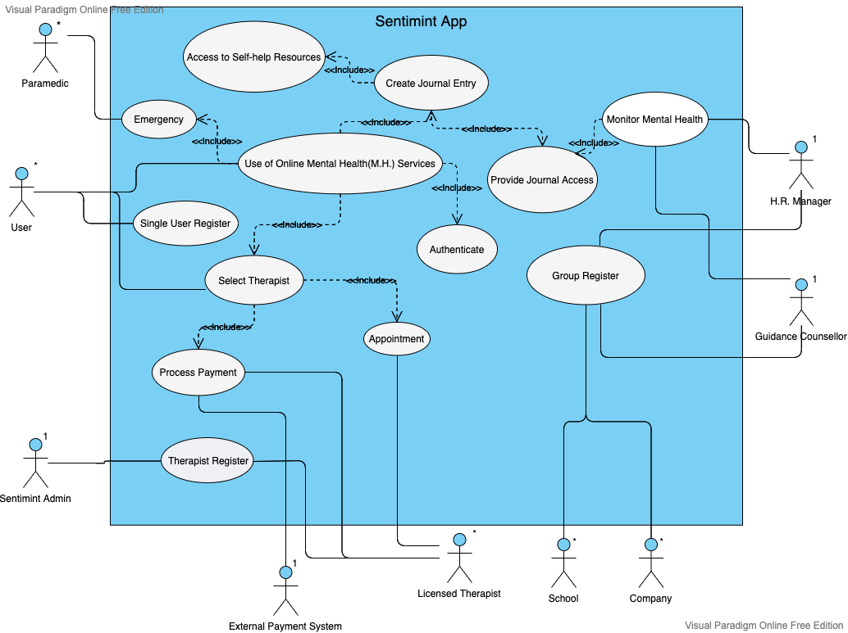

Figure 1: Sentimint Web-App Use Case Diagram

## **B.2. Textual Use Cases**

**Use of Mental Health Services Use Case**

**Use Case:** Use of Mental Health Services

**Scope:** Online Sentimint App

**Level:** Summary

**Intention in Context:** The intention is for mentally-troubled *Users* to find a place to vent their feelings and get professional help.

**Multiplicity:** Multiple *Users* from students, company employees can use the services of Sentimint. A given *User* can only have one active session with Sentimint.

**Primary Actor:** *User* ( can be student or corporate employee as well)

**Main Success Scenario:**

1. *User* Authenticates with the *System*.
2. *System* provides Online Mental Health Services to *User*.
3. *User* Create Journal Entry.

Step 3 can be repeated as many times as the User deems necessary.

1. *User* informs the *System* to logout.
2. *System* informs the *User* of a successful logout.

**Extensions:**

2a. Authenticate is unsuccessful. Use case ends in failure

3||a. *User* stays idle for too long.

3||a.1 *System* informs the *User* that their session has expired due to their inactivity. Use case ends in failure.

3b. *User* chooses Select Therapist

3c. *User* chooses Emergency.

4a. *User* forgets to logout.

4a.1 *System* informs the *user* that their session has expired due to being idle for too long. Use case ends in failure.

**Create Journal Entry Use Case**

**Use Case:** Create Journal Entry

**Scope:** Online Sentimint App

**Level:** User-goal

**Intention in Context:** The intention is for *Users* suffering from mental illnesses to create journal entries.

**Multiplicity:** Multiple *Users* from students, company employees can use the services of Sentimint.

**Primary Actor:** *User* (can be student or corporate employee as well).

**Main Success Scenario:**

1. *User* requests to Create Journal Entry from the *System* for a specific date.
2. The *System* then Create Journal Entry for the specified date to *User*.
3. *User* input their feelings into Journal Entry and select one of the following sentiment options including joy, trust, fear, surprise, sadness, disgust or anticipation.
4. Based on sentiment selection *System* recommends to *User* the most appropriate Access to Self Help Resources content.

**Extensions:**

3a. When *User* creates a new entry, he/she can specify whether they want to share their entry with the H.R. department from that company/institution.

**Access to Self-help Resources Use Case**

**Use Case:** Access to Self-help Resources

**Scope:** Online Sentimint App

**Level:** User-goal

**Intention in Context:** The intention is for *Users* suffering from mental illnesses to seek self-help resources.

**Multiplicity:** Multiple All Users including students and company employees can use the self-help service.

**Primary Actor:** User (can be student or corporate employee as well)

**Main Success Scenario:**

*User accesses Use of Mental Health Services and selects create journal entry.*

1. *System* gives user access to self-help resources that best match the sentiment of journal entry.

2. *User* selects the self-help resource(i.e. an article or quotes) they feel best suits their needs.

*Step 2 is repeated as many times as needed by the user*

**Select Therapist UseCase**

**Use Case:** Select therapist

**Scope:** Online Sentimint App

**Level:** Subfunction

**Intention in Context:** The intention is for the user to select a therapist.

**Multiplicity:** Only one *User* may talk to a *Therapist* at a given time.

**Primary Actor:** *System*

**Secondary Actor:** *Therapist*, *User* (can be student, corporate employee or hospital professional)

**Main Success Scenario:**

1. *User* Selects Therapist of their choice from Therapist List.
2. *User* selects the date and time they would like to meet the *Therapist* based on their availability.
3. *User* pays the required fees.
4. *System* Processes Payment via external payment Service.
5. *System* notifies *User* of successful payment.
6. *System* provides Appointment notice to the *User* and *Therapist*.

**Extensions:**

2a. The *Therapist* is not available at the time the *User* would like to meet.

2a.1. *User* reverts to step 1 and chooses another *Therapist*.

2a.2 Or *User* chooses another day.

4a. The *User* has entered the incorrect information, must re-enter correct information

5a. The *User* has insufficient funds, and is asked to provide another means to pay the amount

6.1. The *Therapist* is unable to meet due to incomplete transactions. Use case fails.

**Appointment Use Case**

**Use Case:** Appointment

**Scope**: Online Sentimint App

**Level**: Subfunction

**Intention in Context:** The intention is for the *User* to book an appointment with a *Therapist*.

**Multiplicity:** Only the user can have access to booking an appointment .

**Primary Actor:** *User* ( can be student or corporate employee as well)

**Secondary Actor:** Therapist

**Main Success Scenario:**

*User accesses Use of Mental Health Services from Sentimint App and selects Therapist.*

1. *User* chooses to book an Appointment with a *Therapist*.
2. *System* list of times available for the *Therapist*.

**Authenticate UseCase**

**Use Case:** Authenticate

**Scope:** Online Sentimint App

**Level:** Subfunction

**Intention in Context:** The intention is for *Users* to authenticate in the Sentimint app.

**Multiplicity:** Multiple *Users* including students and company employees can use the services of Sentimint.

**Primary Actor:** *User* ( can be student or corporate employee as well)

**Main Success Scenario:**

1. *User* provides username and password to the *System*.
2. The *System* then checks the username and password.
3. *System* notifies the *User* of a successful login.

**Extensions:**

2a. The *System* verifies whether the entered usernames and passwords are correct or incorrect.

2a.1. *System* suggests to the *User* to try again. Use case now reverts back to step 1.

2b. *System* verifies that the account is blocked.

2b.1 *System* notifies the *User* about the status of their account. The use case ends in failure.

**Group Register Use Case**

**Use Case:** Group Register

**Scope:** Online Sentimint App

**Level:** User Goal

**Intent in Context:** The intent of the *Company/School* is to register the name of the *School/Company*, the associated *Counselor/H.R. Manager* and a list of associated *Employees/Students* into the Sentiment App.

**Multiplicity:** Many *Companies/School* may register their *Employees/Students* concurrently.

**Primary Actor:** *Company/School*

**Secondary Actor:** *Counselor, H.R. Manager, Students, Employees*

Main Success Scenario:

*Company/School accesses Online Sentiment web app from computer.*

1. *System* communicates with *Company/School* whether to Authenticate or register.

2. Company/School communicates with *System* to register.

3. *System* communicates with *Company/School* for Single User Register, Group Register or Therapist Register.

4. *Company/School* indicates Group Register.

*5.* *System* communicates with *Company/School* for name.

*6.* *Company/School* communicates with *System* and provides name.

7. *System* communicates with *Company/School* of successful name registration.

8. *System* communicates with *Company/School* for *Counsellor/HRmanager*.

9. *Company/School* communicates with *System* and provides name and identification number for *Counsellor/HRmanager*.

10. *System* informs *Company/School* of successful *Counsellor/HRmanager* registration.

11. *System* communicates with *Company/School* for *Student/Employee* name and identification number.

12. *Company/School* communicates with *System* and provides single *Student/Employee* member name and identification number.

13. *System* informs *Company/School* of successful *Student/Employee* registration.

14. *Repeat Step 11-13 until all members associated with Company or School are communicated with system.*

15. *Company/School* communicates with *System* that Group Register of *Student/Employee* is complete.

16. *System* communicates with *Company/School* and acknowledges completion.

17. *System* exits Group Register.

**Extensions:**

7a. *System* asserts to *Company/School* that *Company/School* name is missing, or name is already registered. Use case ends in failure.

*10a. System* asserts to *Company/School* that *Counsellor/HRmanager* name or/and identification number is missing or already registered. Use case ends in failure.

13a. *System* asserts to *Company/School* that *Student/Employee* name or/and identification number is missing or already registered. Use case ends in failure.

**Single User Register Use Case**

**Use case:** Register Single User

**Scope:** Online Sentimint App

**Level:** User goal

**Intention in Context:** The intention of the *User* is to register with the Sentiment App.

**Primary Actor:** *User* ( can be student, corporate employee or hospital professional)

**Multiplicity:** Many *Users* may register concurrently.

*User accesses Online Sentiment web app from computer.*

*1.* *System* communicates with *User* whether to Authenticate or register

*2.* *User* communicates with *System* to register.

*3.* *System* communicates with *User* for Single User Register, Group Register or Therapist Register.

4. *User* indicates Single User Register.

5. *System* communicates with *User* for name.

6. *User* communicates with *System* and provides name.

*7.* *System* communicates with *User* of successful name registration.

8. *System* communicates with *User* for phone number and location.

9. *User* communicates with *System* and provides phone number and location.

*10.* *System* communicates with *User* of successful phone number and location.

*11.* *System* communicates with *User* and acknowledges completion.

*12.* *System* exits Single User Register.

Extension:

7a. *System* asserts to *User* that name is missing, or name is already registered. Use case ends in failure.

8a. *System* asserts to *User* that phone number or/and location is missing or already registered. Use case ends in failure.

**Therapist Register Use Case**

**Use Case:** Therapist Register

**Scope:** Online Sentimint App

**Level:** User goal

**Intention in Context:** The intention of the *Therapist* is to advertise their services on the Online Sentiment App

**Primary Actor:** *Therapist*

**Secondary Actor:** *Sentimint Admin*

**Multiplicity:** Many *Therapists* may register concurrently

**Main Success Scenario:**

*Therapist accesses Online Sentiment web app from computer.*

*1.* *System* communicates with *Therapist* whether to Authenticate or register

*2.* *Therapist* communicates with *System* to register.

*3.* *System* communicates with *User* for Single User Register, Group Register or Therapist Register

4. *Therapist* indicates Therapist Register.

5. *System* communicates with *Therapist* for name, credentials, contact information and summary of services.

6. *Therapist* communicates to *System* name, credentials, contact information and summary of services.

7. *System* communicates successful input of information.

8. *System* prompts *Therapist* for 24 hour review period and exits Therapist Register.

9. *System* forwards *Therapist* name, credentials, contact information and summary of services to *Sentimint Administration* for review.

10. *Sentimint Administration* approves *Therapist* and posts *Therapist* contact under Select Therapist.

Extension:

7a. *System* asserts to *Therapist* missing name, credentials, contact information and/or summary of services. Use case ends in failure.

9a. *Sentimint Administration* does not approve *Therapist*. Use case ends in failure.

**Process Payment Use Case**

**Use Case:** Process Payment

**Scope**: Online Sentimint App

**Level**: Subfunction

**Intention in Context:** The *System* needs to process payment for a diagnosis to occur

**Multiplicity:** Multiple payments might be processed concurrently.

**Primary Actor:***System*

**Secondary Actor:***User* (can be student or corporate employee well), *Therapist, External Payment System*

**Main Success Scenario:**

1.*System* notifies the *External Payment System* of the amount due.

2.*External Payment System* notifies the *System* that the full amount has been paid.

**Extensions:**

2a.*External Payment System* notifies *System* that external payment for the *Therapist* was not completed successfully in its entirety, and about the remaining amount due.

2a.1 *User* has not identified himself as an employee/student.

2a.1a. *System* requests identification of *User.*

2a.1.2a.*User* request *System* to cancel the transaction. The allocated Appointment given to the *User* is removed from the *Therapists* schedule.

**Receive Payment Use Case**

**Use Case:** Receive Payment

**Scope:** Online Sentimint App

**Level:** User Goal

**Intention in Context:**

The Therapist receives payment for the scheduled therapy session/diagnosis.

**Provide Journal Access Use Case**

**Use Case:** Provide Access

**Scope**: Online Sentimint App

**Level**: Subfunction

**Intention in Context:** The intention is for the *User* to provide access to their journal entries to the *H.R. Manager* or the *Guidance Counsellor*.

**Multiplicity:** Many users may provide their journal entry access to the *H.R. Manager* or the *Guidance Counsellor.*

**Primary Actor:***User* ( can be student, corporate employee or hospital professional), Therapist

**Main Success Scenario:**

1. *User* selects Create Journal Entry.
2. *User* selects Provide Journal Access for *the H.R. Manager/Guidance Counsellor* to view the journal.
3. *System* generates an encryption key.
4. *User* provides the encryption key to *H.R. Manager/Guidance Counsellor* offline.

**Monitor Mental Health Use Case**

**Use Case:** Monitor Mental Health

**Scope**: Online Sentimint App

**Level**: User-goal

**Intention in Context:** The intention is for the *H.R. Manager* or the *Guidance Counsellor* to review the mental health status of an *Employee* or a *Student* (if authorized by the user).

**Multiplicity:** One *H.R. Manager* or the *Guidance Counsellor* can view the *User’s* journal entry at a time.

**Primary Actor:** *H.R. Manager/Guidance Counsellor*

**Main Success Scenario:**

*H.R. Manager/Guidance Counsellor accesses Sentiment web app from computer.*

1. *H.R. Manager/Guidance Counsellor* selects the Provide Journal Access.
2. *H.R. Manager/Guidance Counsellor* enters the user’s identification along with the encrypted key.
3. *System* redirects *H.R. Manager/Guidance Counsellor* to the journal page of the specified account.
4. *H.R. Manager/Guidance Counsellor* is able to view only the list of journal entries of the *User.*

**Extensions:**

2a. The *H.R. Manager/Guidance Counsellor* enters the incorrect encryption key or the credential.

2a.1. *H.R. Manager/Guidance Counsellor* reverts to step 5 and re-enters the credential along with the encrypted key.

**Emergency Use Case**

**Use Case:** Emergency

**Scope**: Online Sentimint App

**Level**: User-goal

**Intention in Context:** The intention is for the User to contact emergency services.

**Multiplicity:** Only the user can have access to the emergency number.

**Primary Actor:** *User* ( can be student, corporate employee or hospital professional)

**Secondary Actor:** Paramedic

**Main Success Scenario:**

*User accesses Use of Mental Health Services from Sentimint App.*

1. *User* selects Emergency.
2. *System* provides contact to *Paramedic*.

## **B.3. Domain Model**

See Figure 2 for Domain model derived from the Use case model (Figure 1) and Project requirements.

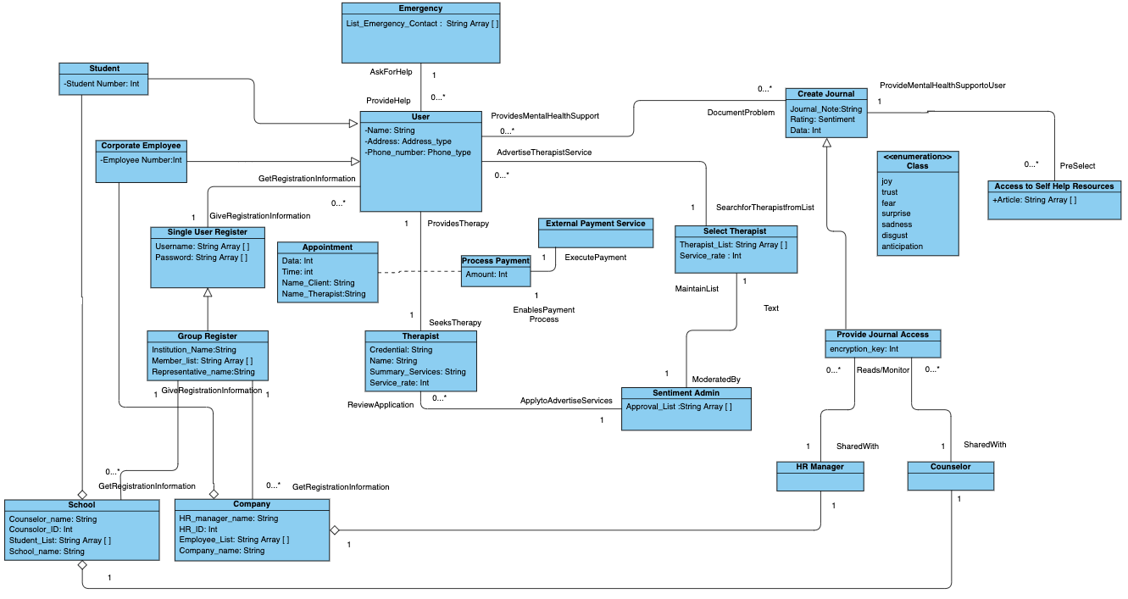

Figure 2: Sentiment App. Domain Model

# **C. Task 1 - Architectural Design**

## **C.1. Introduction**

The architectural design pattern that we chose to use was a combination of Client and Server with MVC(Model View Controller). We chose a client and server to differentiate between the frontend and the backend respectively. The client will send a request to the server from the browser and the server will respond back with a response using the browser. This means that client and server use the browser to communicate to one-another. The benefit of using Client and Server is that it is ideal for modelling a set of services where clients can request them which fits our project as the client should be able to request a slew of services1. The cons of this architectural design is that requests are typically handled in separate threads on the server and inter-process communication requires overhead1. To mitigate the backend(i.e. server) issues, we decided to make the backend a MVC and this is depicted in detail in Figure 1. For the frontend (i.e. Client), we know it will be used by different users such as Student, Employee, HR Manager, Counsellor , Therapist, Company, School and Sentiment Admin.

The MVC architecture in the backend is divided into three main logical components of Model, a View and Controller. The model contains the core functionality and data, the view displays the information to the user (more than one view may be defined) and the controller handles the input from the user1. The advantage of using the MVC pattern is that it is easy to have multiple views of the same model and the views can be connected or disconnected at run-time1. Some other advantages of MVC include faster development, easy for multiple developers to collaborate and work together, easy to update the application and easy to Debug as we have multiple levels properly written in the application2. The downside is that the model can become complex with time making it hard to understand2. As well, it must have strict rules on methods1. In our design pattern, the server is what harbours the Model, View and Controller. The controller manipulates data from the model. Whereas, the model will update and notify change to the view. The Model also has the Database server.

Finally, it is important to note that any good system design is one that reduces system complexity while allowing changes. This is possible because of high coherence and low coupling. Coherence is a measure of how classes depend on each other. High coherence means that classes in the subsystem perform similar tasks and are related to each other through associations. Coupling refers to how subsystems depend on each other. Low coupling in particular occurs when a change in one subsystem does not affect change in any other subsystem. Our entire project ensures that good system design is met hence, we have high coherence and low coupling in our project.

## **C.2. Architectural Model (Revised)**

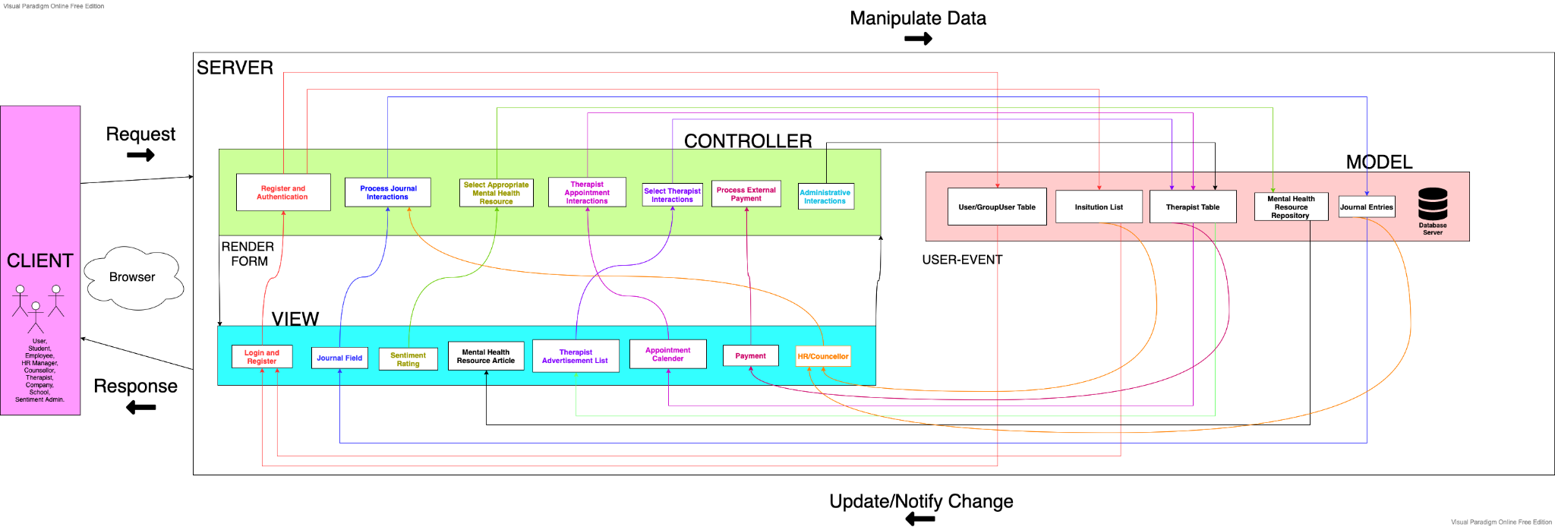

Figure 3: Architectural Diagram (MVC + Server Client Model) (Revised)

# **D. Task 2 - Detailed Design**

## **D.1. Interaction Model (Sequence Diagrams)**

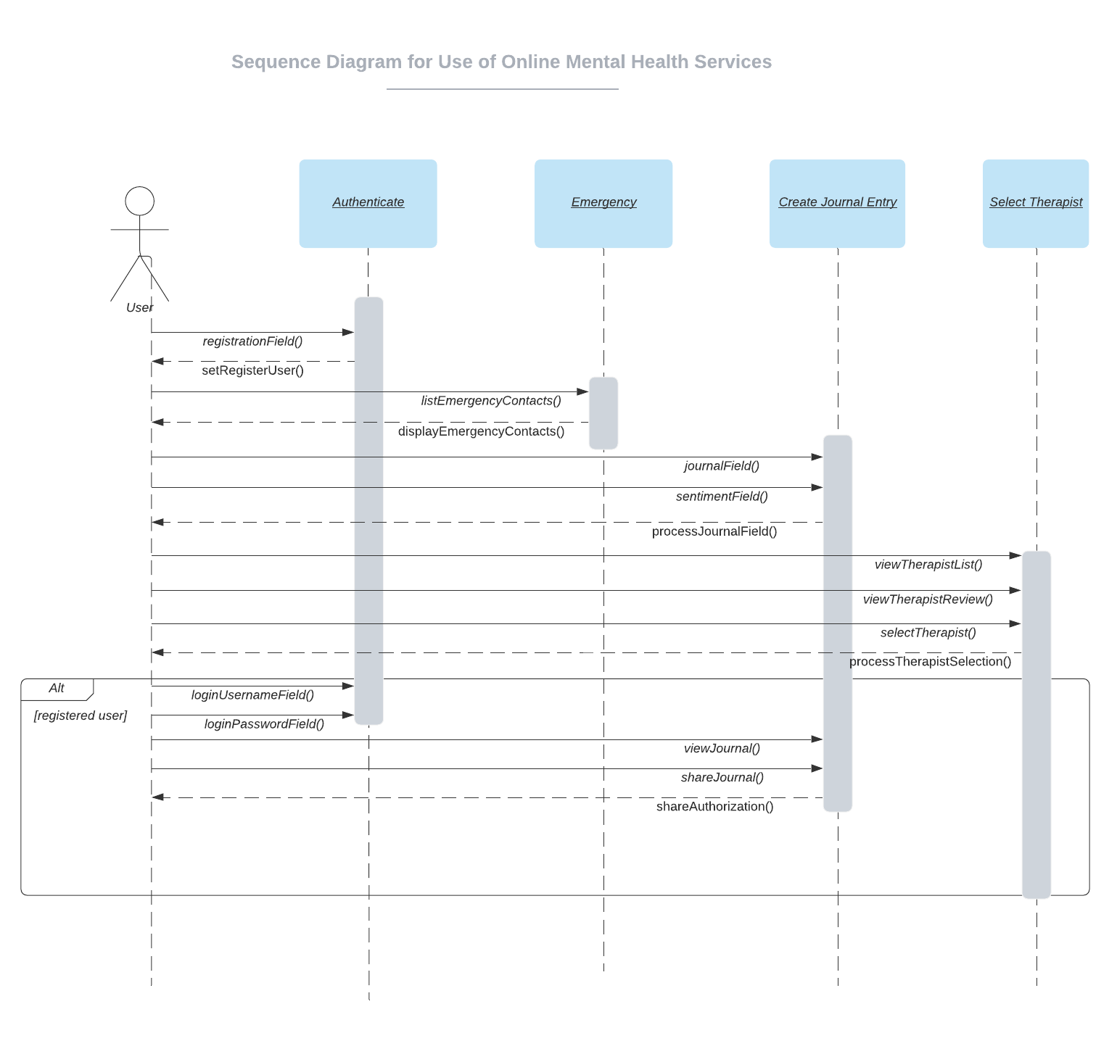

Figure 4: Sequence Diagram for Use of Online Mental Health Resources Use Case

The above figure shows how the User (actor) interacts within the system to access the Use of Online Mental Health Services.

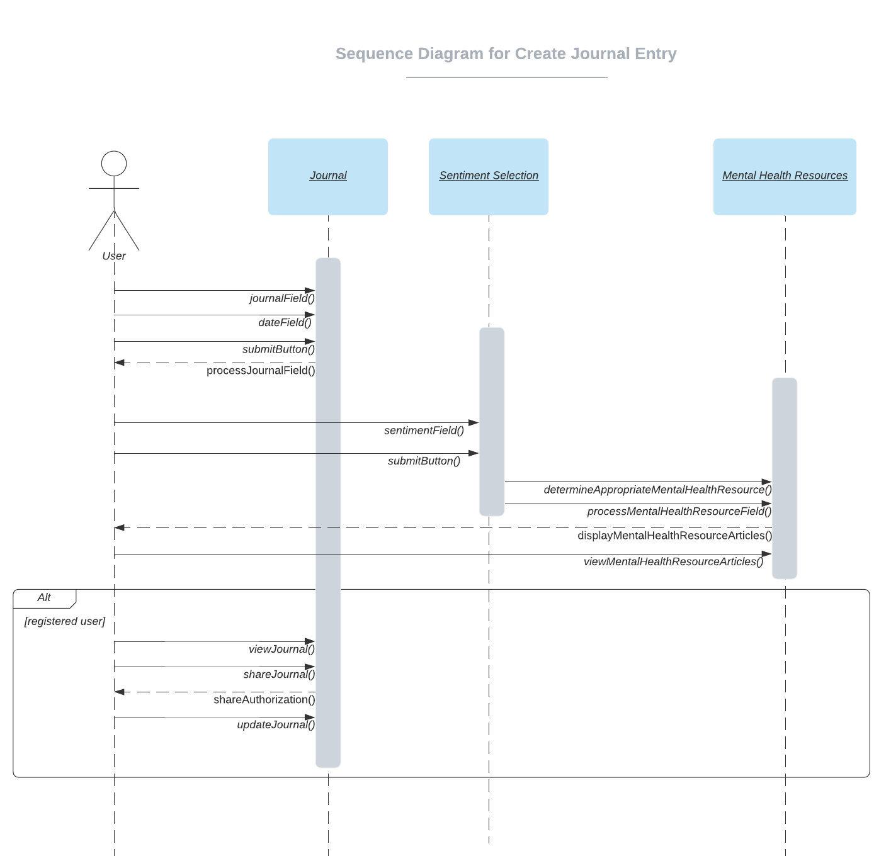

Figure 5: Sequence Diagram for Create Journal Entry Use Case

The above figure shows how the User (actor) interacts within the system to successfully create a journal entry.

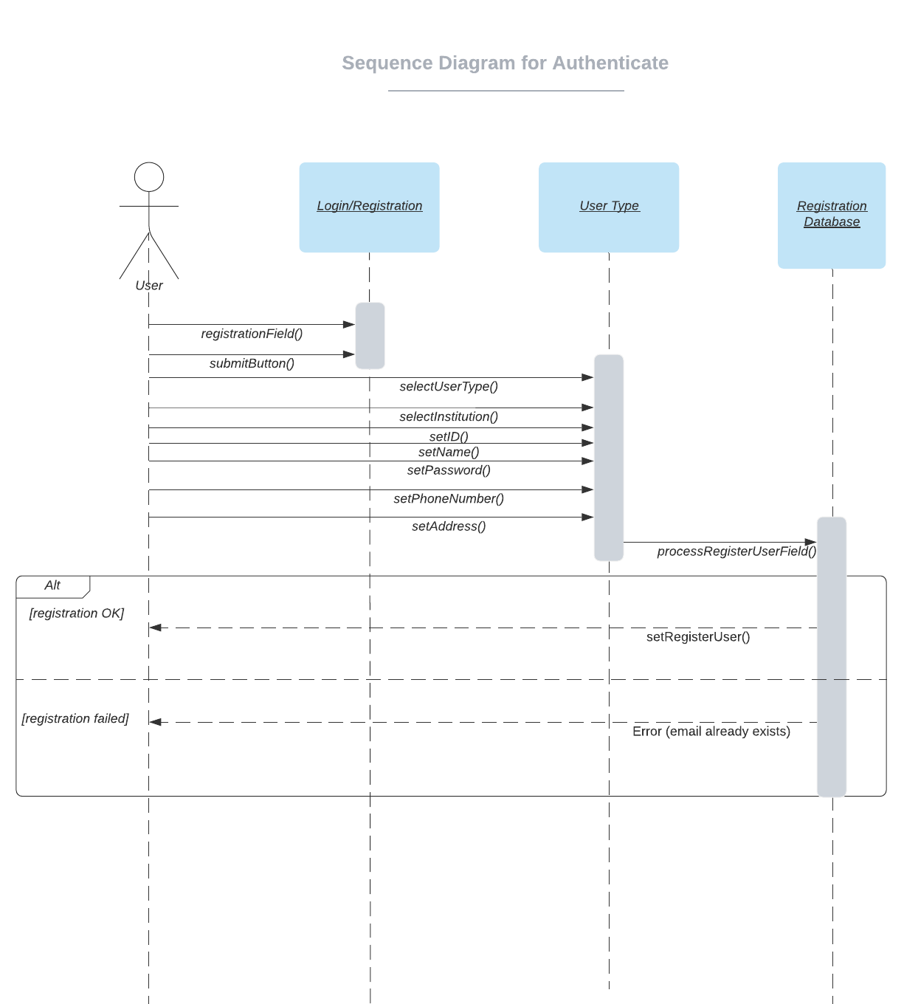

Figure 6: Sequence Diagram for Authenticate Use Case

The above figure shows how the User (actor) interacts within the system to successfully authenticate the login/registration process.

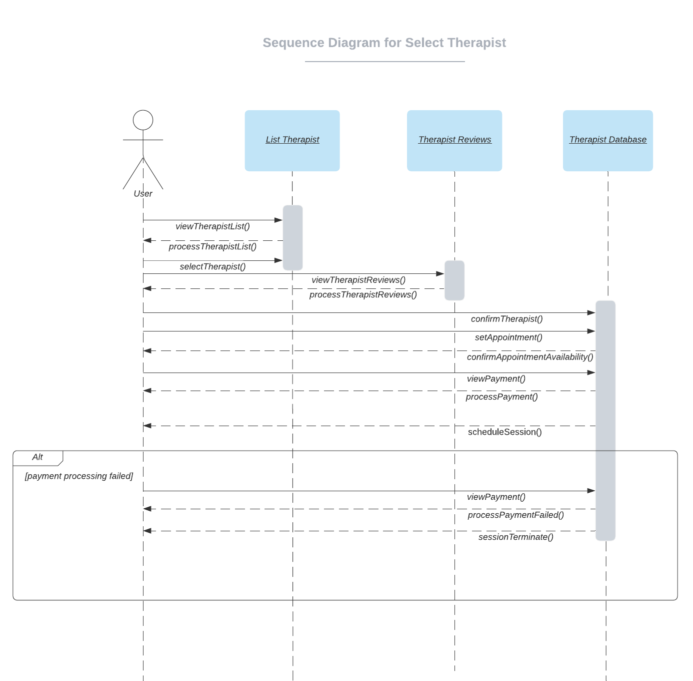

Figure 7: Sequence Diagram for Select Therapist Use Case

The above figure shows how the User (actor) interacts within the system to select a Therapist, process a payment and successfully schedule an appointment.

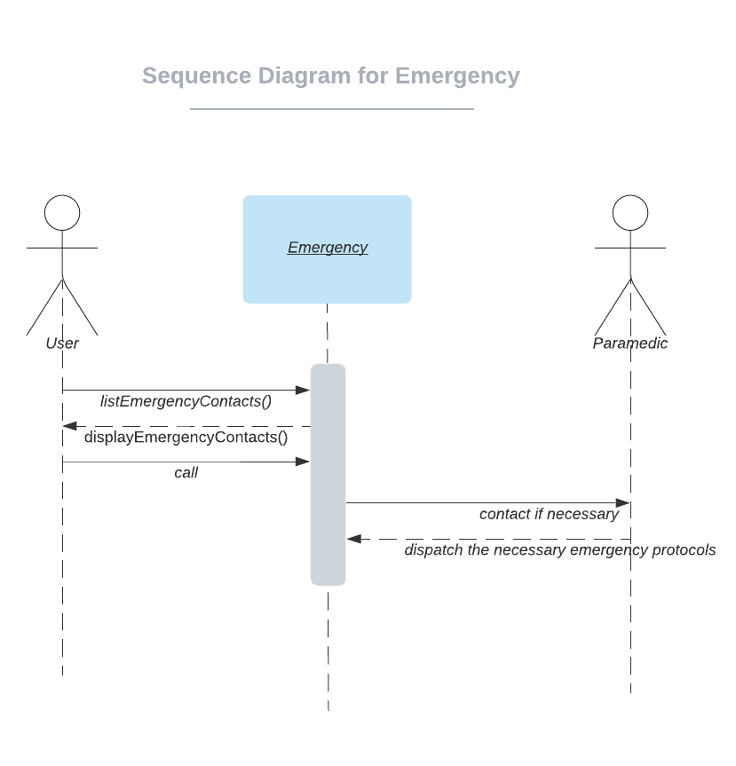

Figure 8: Sequence Diagram for Emergency Use Case

The above figure shows the interaction between a User (actor) and a Paramedic (actor) within the system in the case of an emergency.

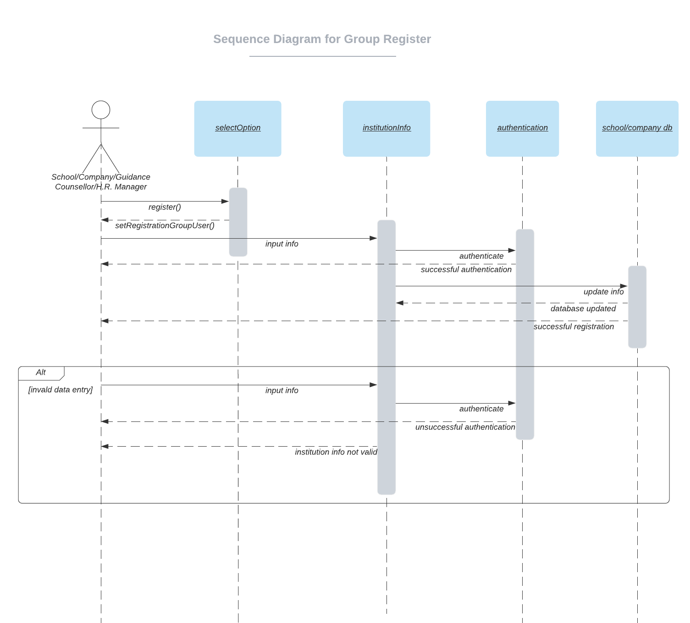

Figure 9: Sequence Diagram for Group Register Use Case

The above figure shows how the School/Company/Guidance Counsellor/H.R. Manager (actor) interacts within the system to form a group register.

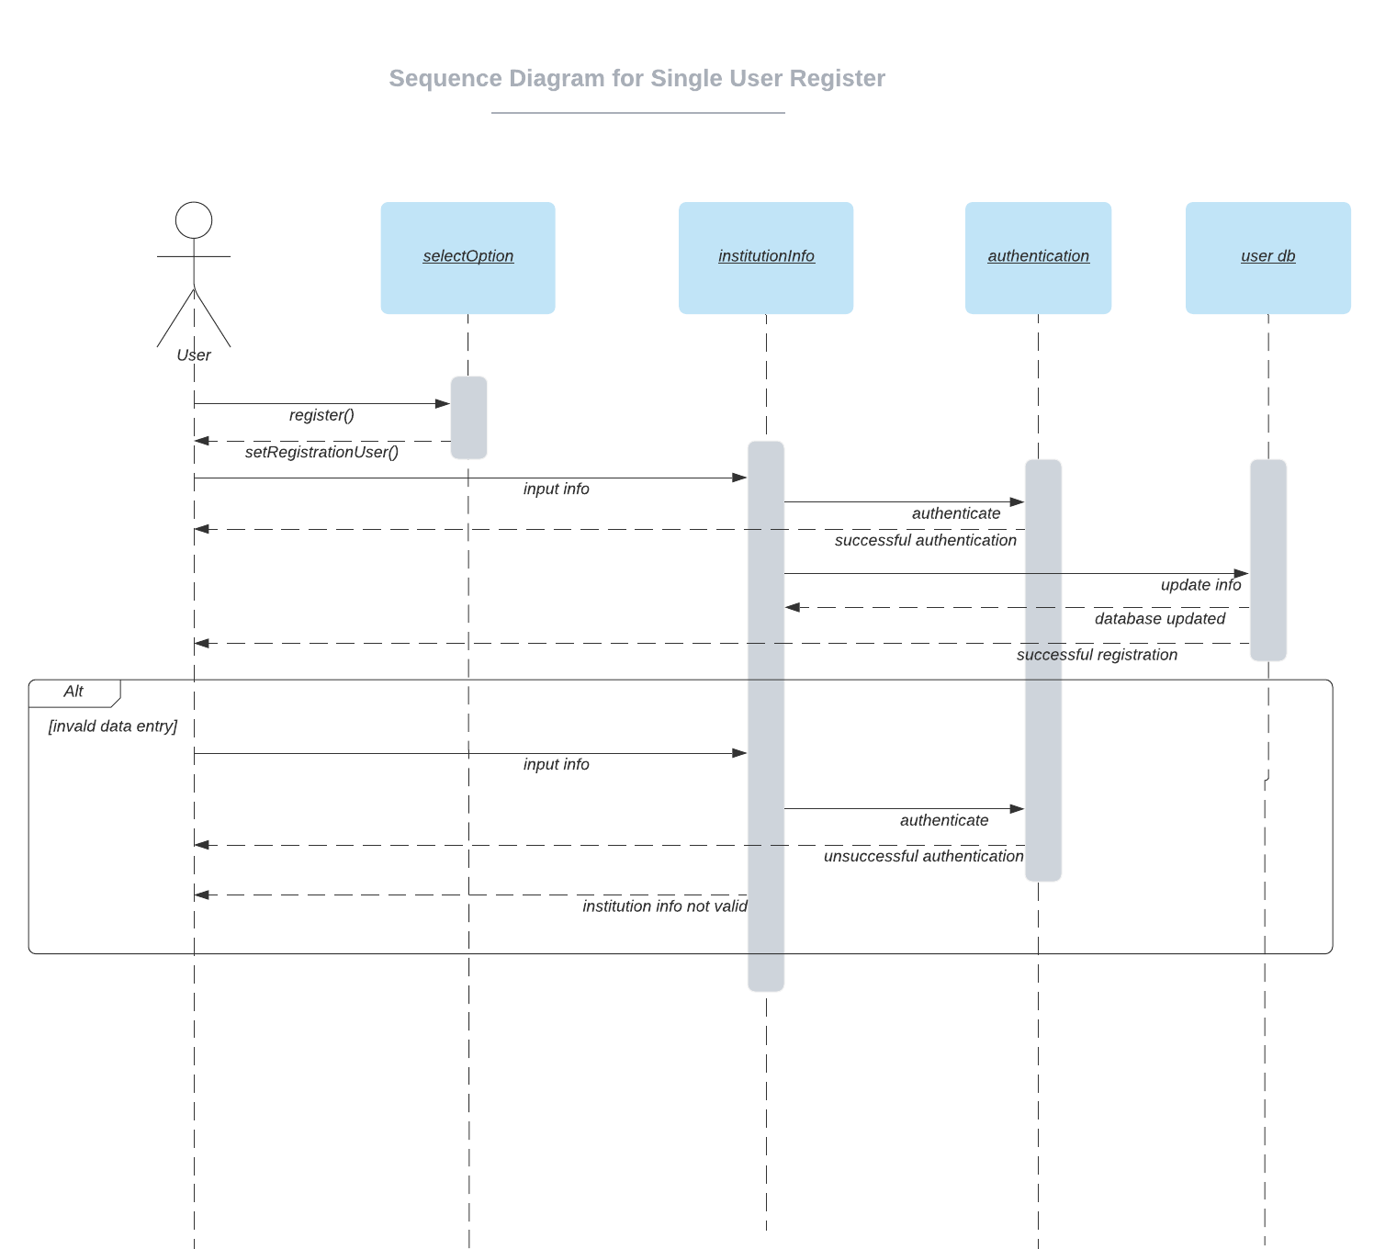

Figure 10: Sequence Diagram for Single User Register Use Case

The above figure shows how the User (actor) interacts within the system to register as a stand alone user.

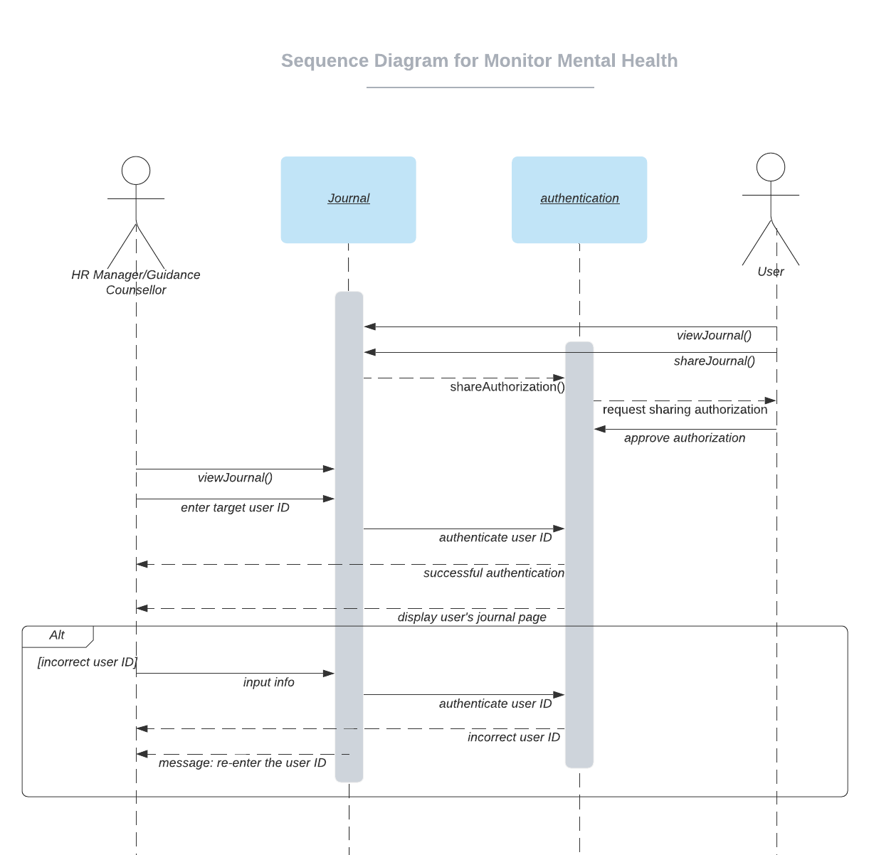

Figure 11: Sequence Diagram for Monitor Mental Health Use Case

The above figure shows how the H.R. Manager/Guidance Counsellor (actor) interacts within the system to view the target user’s (actor) journal entries.

Figure 12: Sequence Diagram for Therapist Register Use Case 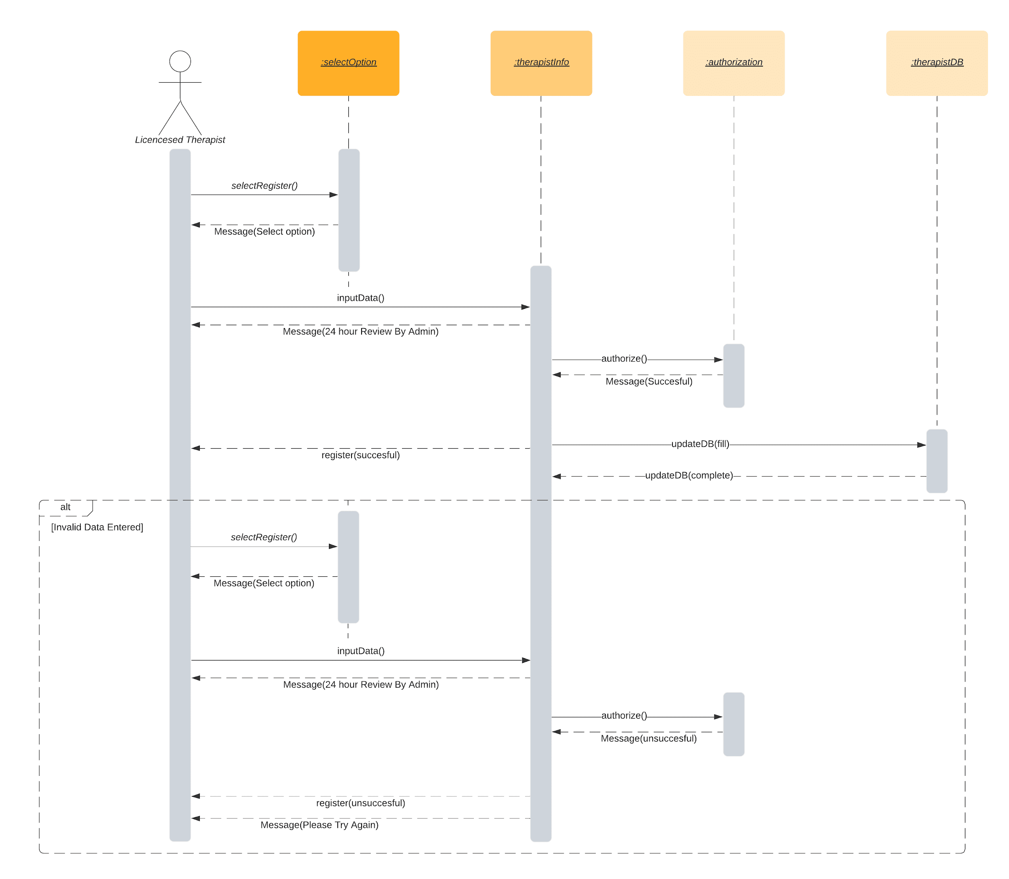

The above figure shows how a Therapist interacts with the system to self register.

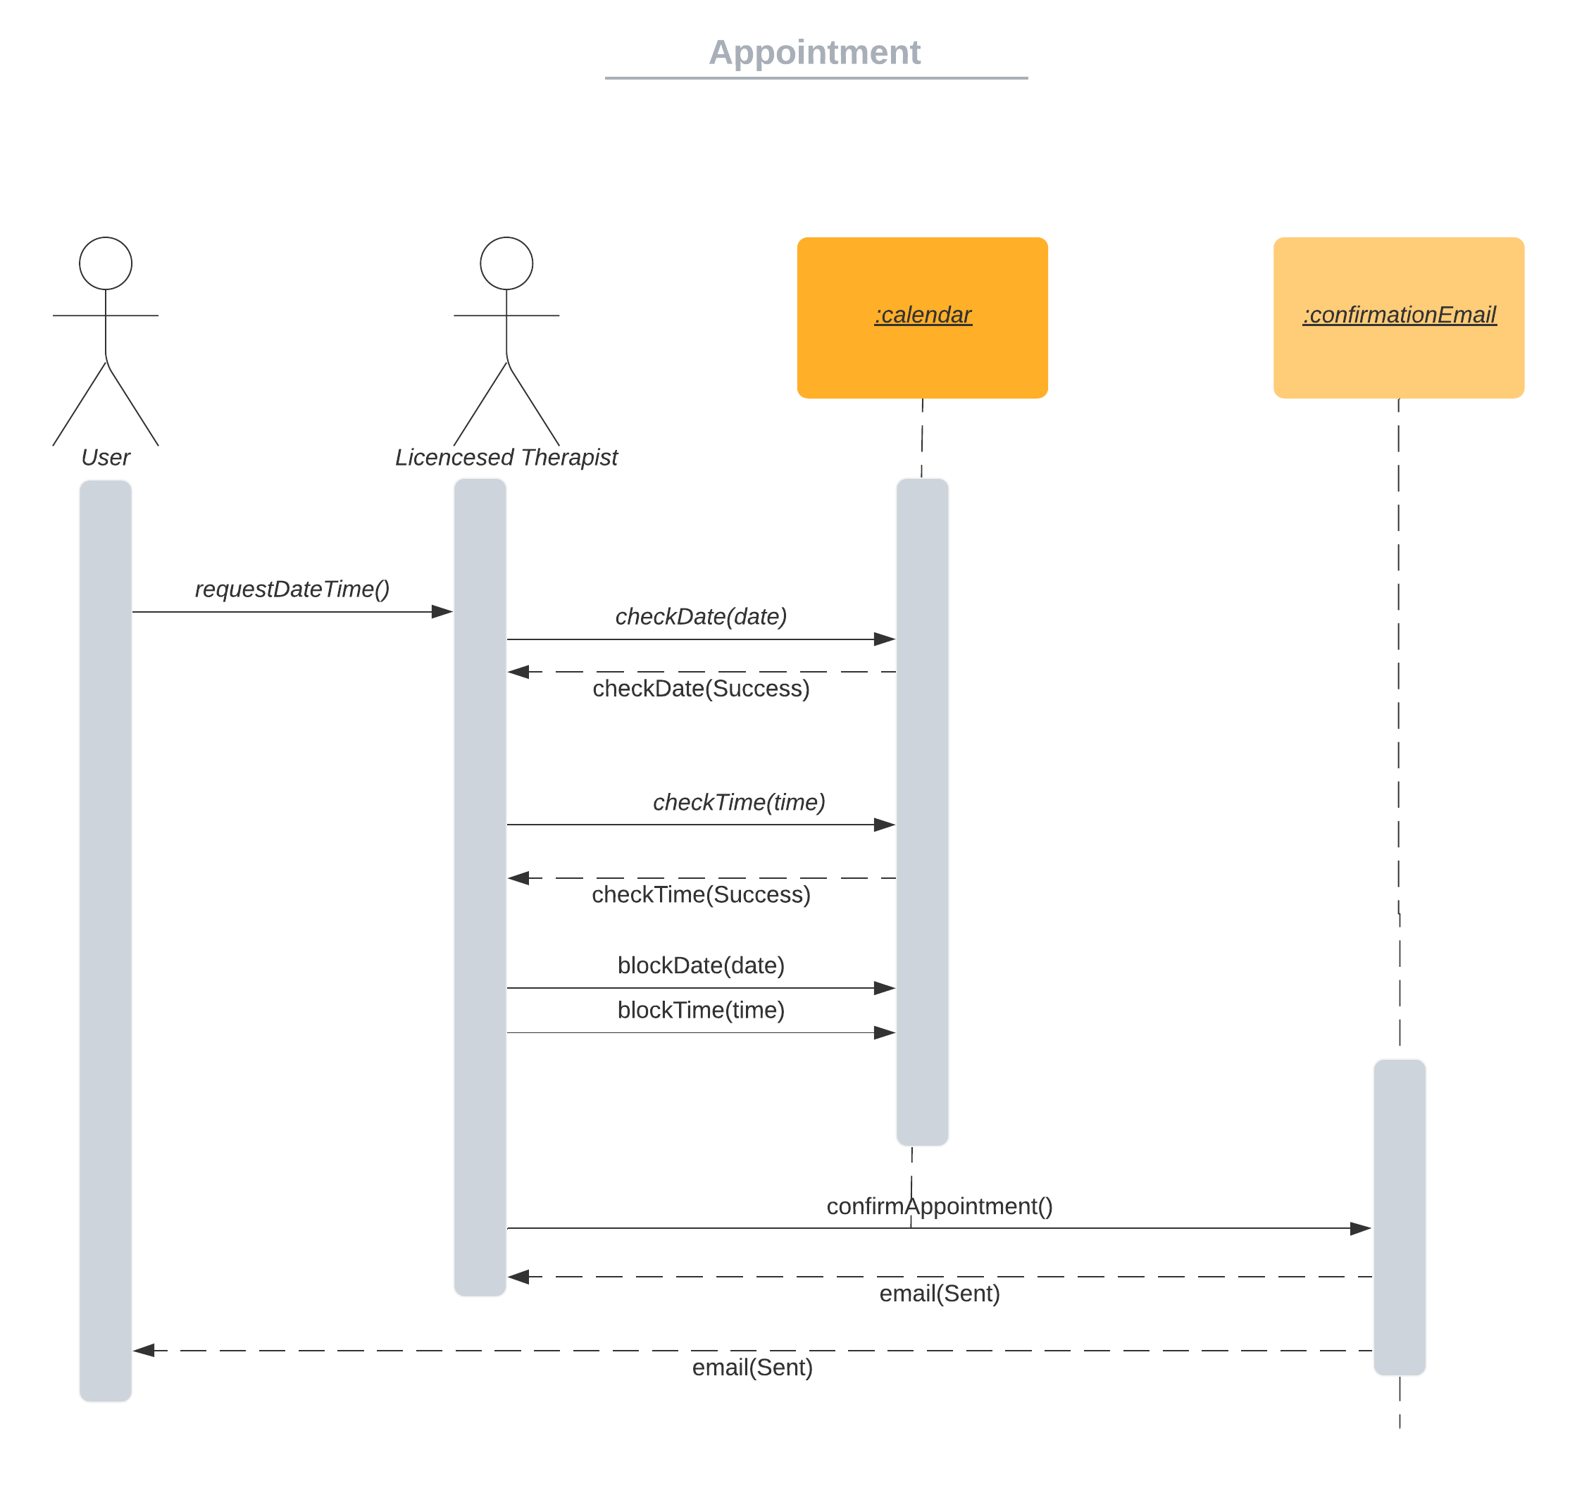

Figure 13: Sequence Diagram for Appointment Use Case

The above figure shows how the Licensed Therapist (actor) interacts within the system to book an appointment created by the User (actor).

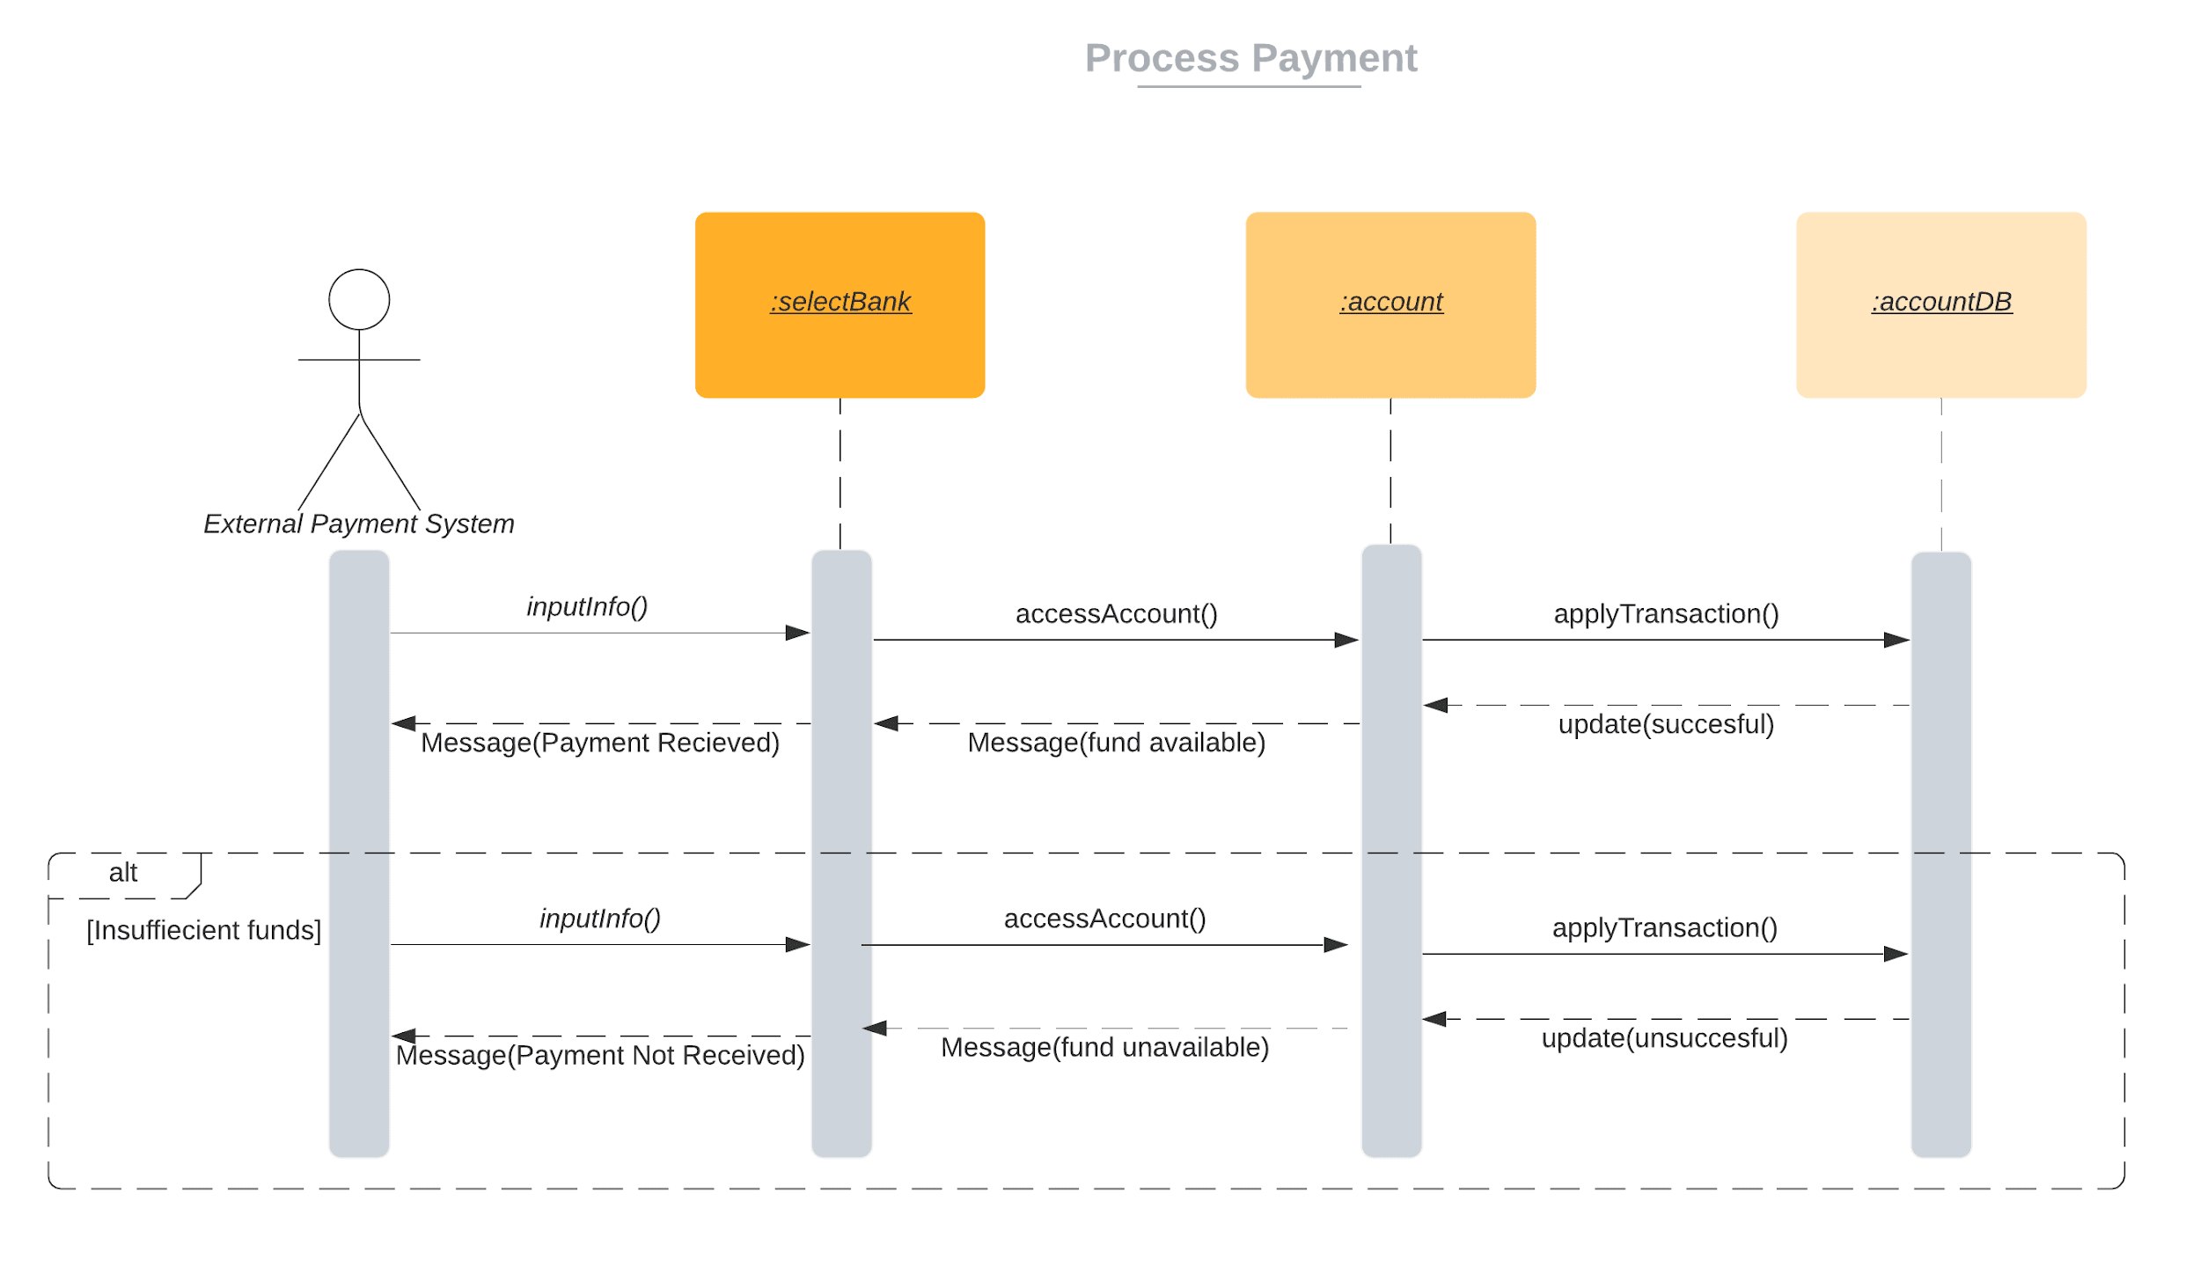

Figure 14: Sequence Diagram for Process Payment Use Case

The above figure shows how the External Payment System (actor) interacts within the system to successfully process a payment.

## 

## **D.2 Design Class Model(Revised)**

## 

## 

## 

## 

## 

## 

## 

## 

## 

## 

## 

## 

Figure 15: Class Diagram (Revised)

## **D.3. State Machine Model (Revised)**

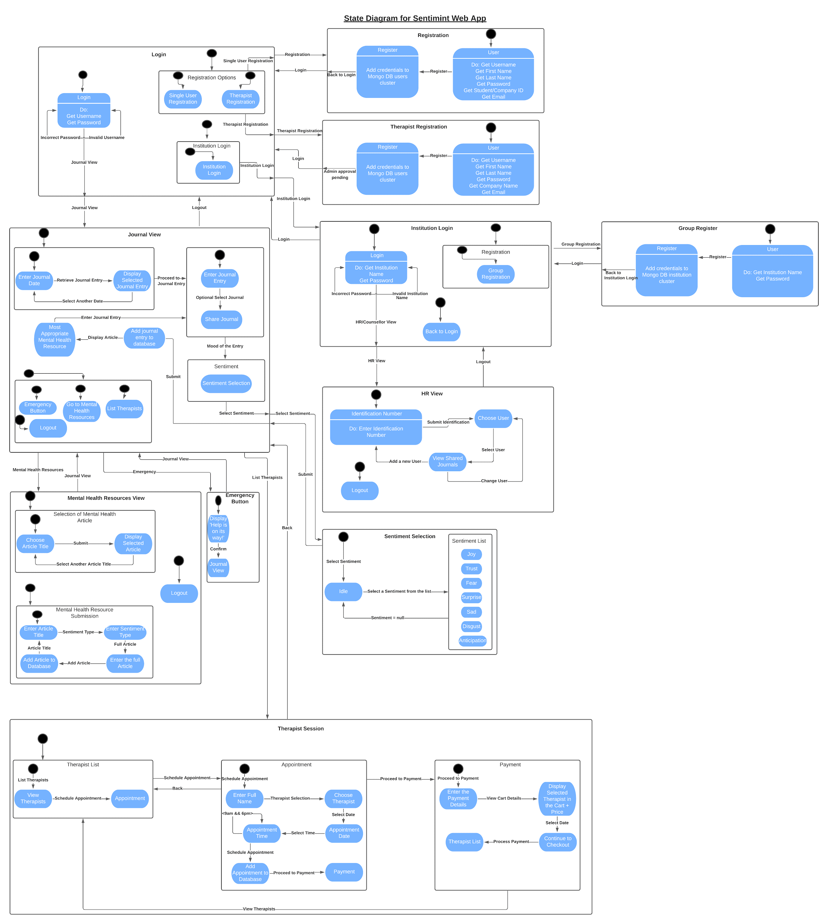

Figure 16: State Diagram of Sentimint Web Application (Revised)

During the course of the implementation phase, the state diagrams underwent some revisions that were integral to the functioning of the application. The login state diagram was revised with three registration options: Single User Registration, Therapist Registration and Institution Login. The single user/therapist registration was revised with similar options. The group registration view from the previous state diagram was modified to Institution Login. The Journal view was revised by merging the functionalities of Journal Entry and Sentimint Selection. Moreover, the Most Appropriate Mental Health Resources was also added to the Journal View page. The Sentiment Selection state was cleaned up by removing the redundant transitions between the idle state and the sentiment list. Finally, the Therapist Session was revised by adding more inputs to the Appointment state diagram such as the user’s Full Name, Therapist Name, Appointment Time and the button to add the scheduled appointment to the database. Since the initial assumption as per the test cases was that the Payment details would be handled by a third party service provider, we decided that the credential details would not be added to the database. Hence, there was no way for us to verify that the payment details were valid. Thus, upon checkout, the user’s credentials are not validated (assuming that they are correct) and he/she is redirected to the Therapist List view.

# **E. Task 3 - Implementation**

## **E.1. Introduction**

* Discussion on design and implementation decisions made

Through the lab component of the course, a simple to-do list was implemented to help show the students how to use different web application development tools and frameworks. These technologies included but were not limited to: HTML (HBS in Node JS), CSS, JavaScript, Node JS, as well as other Express technologies, MongoDB, and design tools such as Visual Paradigm. As a result it was in the best interest of the group to use the above mentioned technologies to create the web application. While respecting the Architecture and Class model, as well as influence put on using a design pattern helped structure and create the web application. Design tools and requirements models allowed for the logic of the application to be visualized which helped create and finalize the logic behind the various components.

The Prototype created in phase 1 of the project, provided the team with a clear understanding of how the logical flow of the web application should work, as well as what components should or should not be implemented. The prototype also worked as a template of how the UI components would be structured, which during implementation helped structure the order of the HBS/HTML files. Although the styling components may have varied, the locations and structure of specific elements that were seen in the prototype were also used to create the elements in the final web application.

Implementation decisions made:

Due to the time, resource and knowledge constraints there were unfortunately a few implementation decisions that were to be made. These were originally introduced in the proposal and phase 1 reports but, as implementation continued, it was best decided to alter or remove the following functionality.

1. No Administrator functionality:

At the beginning of the project the group decided it was best to have an administrator user who would oversee the website, choose to accept or decline therapists who have registered to use the application, and finally to add mental health articles to the website. As implementation continued it was decided that it was best not to include this as it would have increased the complexity of the final product, and also would have disrupted the architecture and potential design patterns used in this application.

1. Mental Articles can be added by any registered user:

As mentioned above, it was discussed earlier that only the admin would be able to add mental health articles to the web application. Due to removal of the admin functionality all registered users would have the ability to upload mental health articles. This was seen as beneficial as it would allow for users themselves to add the articles, which created a community like feeling. This replication can be seen in web apps such as stack overflow or medium, where users themselves can publish articles, or questions to a public forum.

1. Originally the web application was to mimic a single page application. In addition, during implementation it was decided that splitting the web application into multiple pages would allow for all members of the group to be able to contribute and work on the project. This allowed for problems to be avoided during merging of branches.

## **E.2. Design Pattern**

The type of design pattern chosen for this project was a MVC & Observer design pattern. This design pattern specifies that an application consist of a model view, information view, and control view. The pattern requires that each of these be separated into different objects. The MVC & Observer design pattern was used for the design pattern of the system during the implementation. This was highlighted in our project, and was also reflected in the architectural model project as well. The figure below shows the integration of the MVC & Observer design pattern.

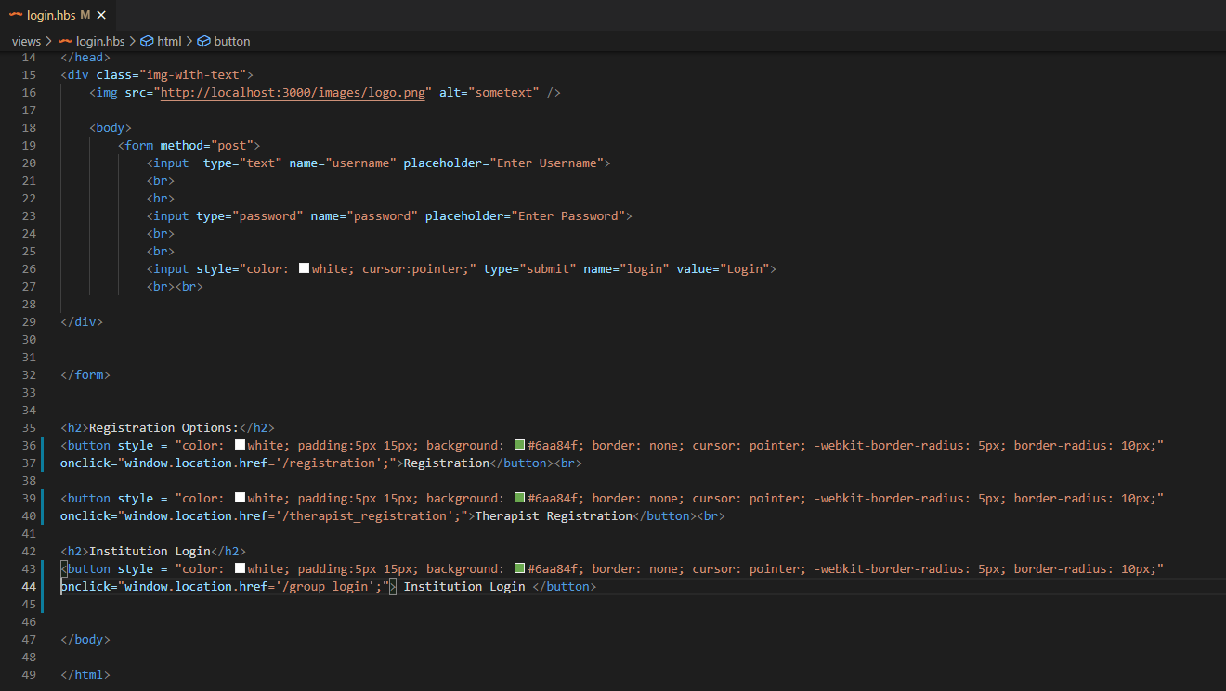

Figure 17: MVC & Observer Design Pattern Implementation

# **F. Testing**

## **F.1. Test Cases**

Below you will see the list of test cases as well as how well each of them performed after system testing.

**Authenticate Test Case**

The User authenticates using the login portal.

Table 2.1: Authenticate Test Case: A

|  |  |  |  |  |
| --- | --- | --- | --- | --- |
| Test cases | Steps | Input | Expected Result | Result after testing |
| A | Authenticate |  |  |  |
| 1 | User Enter account details | …. | User can enter the specific details | ✔ |
| 2 | System Informs user of successful login | …. | User views success message | ✔ |

Table 2.2: Authenticate Test Case: B

|  |  |  |  |  |
| --- | --- | --- | --- | --- |
| Test cases | Steps | Input | Expected Result | Result after testing |
| B | Authenticate-Invalid Information |  |  |  |
| 1 | Enter account details | …. | User can enter (incorrect) details | ✔ |
| 2 | System Informs user of unsuccessful login | …. | User views error message | ✔ |

**Access to Self-help Resources Test Case**

User access Mental Health Resources for self improvement.

Table 3: Access to Self-Help Resources Test Case: A

|  |  |  |  |  |
| --- | --- | --- | --- | --- |
| Test cases | Steps | Input | Expected Result | Result after testing |
| A | Access to Self-help Resources |  |  |  |
| 1 | User views list of self-help resources |  | User views list of self-help resources | ✔ |
| 2 | User can pick from a list of self-help resources. |  | User selects which self-help resource would help them the most. | ✔ |

**Select Therapists Test Case**

User procures service of therapist from “Therapist Advertisement List”.

Table 4.1: Select Therapist Test Case: A

|  |  |  |  |  |
| --- | --- | --- | --- | --- |
| Test cases | Steps | Input | Expected Result | Result after testing |
| A | Select Therapists |  |  |  |
| 1 | User views list of therapists |  | User views list of therapists | ✔ |
| 2 | User picks from therapist and pays the amount owing |  | User views success message | ✔ |

Table 4.2: Select Therapist Test Case: B

|  |  |  |  |  |
| --- | --- | --- | --- | --- |
| Test cases | Steps | Input | Expected Result | Result after testing |
| B | Select Therapists-Invalid Information |  |  |  |
| 1 | User views list of therapists |  | User views list of therapists | ✔ |
| 2 | System informs user of unsuccessful selection of therapist due to incorrect account information. |  | User views error message | ✔ |

**Book Appointment** **Test Case**

User books an appointment with a selected therapist.

Table 5: Book Appointment Test Case: A

|  |  |  |  |  |
| --- | --- | --- | --- | --- |
| Test cases | Steps | Input | Expected Result | Result after testing |
| A | Book Appointment |  |  |  |
| 1 | User views available times with therapist | …. | User views times of therapists available | ✔ |
| 2 | User chooses a time that best suits their needs | …. | User views success message | ✔ |

**Group Register** **Test Case**

An institution such as a school or company registers their students or employees to provide mental health support for their respective members.

Table 6: Group Register Test Case: A

|  |  |  |  |  |
| --- | --- | --- | --- | --- |
| Test cases | Steps | Input | Expected Result | Result after testing |
| A | Group Register |  |  |  |
| 1 | Company/School picks group register option. | … | Company/School picks group register option. | ✔ |
| 2 | Company/School is allowed to register their organization. | ... | Company/School views successful message after group register option. | ✔ |

**Single User Register Test Case**

New user registers with Sentiment Mental Health web application.

Table 7.1: Single User Register Test Case: A

|  |  |  |  |  |
| --- | --- | --- | --- | --- |
| Test Case | Steps | Input | Expected Result | Result after testing |
| A | Single User Register |  |  |  |
| 1 | User selects register button | … | View Single User Register, Group User or Therapist Register options | ✔ |
| 2 | User selects single user select button | … | View data fields to enter name, password, location and phone number | ✔ |
| 3 | User inputs user information into appropriate data fields | name, password, location, phone number | View successful registration message | ✔ |

Table 7.2: Single User Register Test Case: B

|  |  |  |  |  |
| --- | --- | --- | --- | --- |
| Test Case | Steps | Input | Expected Result | Result after testing |
| B | Single User Register  (invalid/incomplete) |  |  |  |
| 1 | User selects register button | … | View Single User Register, Group User or Therapist Register options | ✔ |
| 2 | User selects single user select button | … | View data fields to enter name, password, location and phone number | ✔ |
| 3 | User inputs user information into appropriate data fields and select submit button  (Invalid/incomplete) | name, password, location, phone number  (Invalid/incomplete) | (Invalid/incomplete)    View unsuccessful registration message | ✔ |

**Therapist Register Test Case**

New Therapist registers services with Sentiment Mental Health web application.

Table 8.1: Therapist Register Test Case: A

|  |  |  |  |  |
| --- | --- | --- | --- | --- |
| Test Case | Steps | Input | Expected Result | Result after testing |
| A | Therapist Register |  |  |  |
| 1 | User selects register button | … | View Single User Register, Group User or Therapist Register options | ✔ |
| 2 | User selects Therapist select button | … | View data fields to enter name, password, credentials, phone number, location and summary of services | ✔ |
| 3 | User inputs user information into appropriate data fields | name, password, credentials, phone number, location and summary of services | View successful registration and 24hour review notice | ✔ |
| 4 | Admin reviews therapist application | … | Admin can view Therapist application | ✔ |
| 5 | Admin manually approves Therapist by selecting therapist and selecting add button | … | Therapist added to “Therapist Advertisement List” | ✔ |

Table 8.2: Therapist Register Test Case: B

|  |  |  |  |  |
| --- | --- | --- | --- | --- |
| Test Case | Steps | Input | Expected Result | Result after testing |
| B | Therapist Register  (invalid/incomplete) |  |  |  |
| 1 | User selects register button | … | View Single User Register, Group User or Therapist Register options | ✔ |
| 2 | User selects Therapist user select button | … | View data fields to enter name, password, credentials, phone number, location and summary of services | ✔ |
| 3 | User inputs user information into appropriate data fields  (Invalid/incomplete) | name, password, credentials, phone number, location and summary of services  (Invalid/incomplete) | (Invalid/incomplete)    View unsuccessful registration message | ✔ |

Table 8.3: Therapist Register Test Case: C

|  |  |  |  |  |
| --- | --- | --- | --- | --- |
| Test Case | Steps | Input | Expected Result | Result after testing |
| C | Therapist Register  (not approved) |  |  |  |
| 1 | User selects register button | … | View Single User Register, Group User or Therapist Register options | ✔ |
| 2 | User selects Therapist user select button | … | View data fields to enter name, password, credentials, phone number, location and summary of services | ✔ |
| 3 | User inputs user information into appropriate data fields | name, password, credentials, phone number, location and summary of services | View successful registration and 24hour review notice | ✔ |
| 4 | Admin reviews therapist application | … | Admin can view Therapist application | ✔ |
| 5 | Admin manually disapproves Therapist by selecting therapist and selecting remove button | … | Therapist removed from Admin application Therapist not added to “Therapist Advertisement List” | ✔ |

**Process Payment Test Case**

User makes payment to Therapist for services.

Table 9.1: Process Payment Test Case: A

|  |  |  |  |  |
| --- | --- | --- | --- | --- |
| Test Case | Steps | Input | Expected Result | Result after testing |
| A | Process Payment |  |  |  |
| 1 | User presented with total amount due    User pays Therapist through an external payment service. | … | Therapist received confirmation of payment by external payment service.    Appointment confirmation message for both User and Therapist.    Appointment added to database. | ✔ |

Table 9.2: Process Payment Test Case: B

|  |  |  |  |  |
| --- | --- | --- | --- | --- |
| Test Case | Steps | Input | Expected Result | Result after testing |
| B | Process Payment  (no/invalid payment) |  |  |  |
| 1 | User presented with total amount due    User does not pay Therapist or pays an incorrect amount to the external payment service. | … | Error message presented for no confirmation of payment to User and Therapist. | ✔ |

**Create Journal Entry Test Case**

User creates a journal entry and selects the most appropriate sentiment to describe their current state. Consequently, the user receives the most appropriate “Mental Health Resources Articles” based on sentiment selected.

Table 10: Create Journal Entry Test Case: A

|  |  |  |  |  |
| --- | --- | --- | --- | --- |
| Test Case | Steps | Input | Expected Result | Result after testing |
| A | Create Journal Entry |  |  |  |
| 1 | User input “thoughts/sentiments” into journal field and selects submit button | Text “thought/sentiment” | Journal entry recorded to database | ✔ |
| 2 | User selects the Sentiment that best describes their state from the list. | ... | Presented appropriate Mental Health Resources | ✔ |

**Monitor Mental Health Test Case**

HR manager or school guidance counsellor reviews the mental state of associated students or employees based on contents of shared journals entries.

Table 11: Monitor Mental Health Test Case: A

|  |  |  |  |  |
| --- | --- | --- | --- | --- |
| Test Case | Steps | Input | Expected Result | Result after testing |
| A | Monitor student/employee journal |  |  |  |
| 1 | HR/Counsellor selects student/employee of interest from list who have shared journal entries and select submit button | … | View student/employee journal | ✔ |

**Emergency Test Case**

In case of emergency, users can request help via external emergency services.

Table 12: Emergency Test Case: A

|  |  |  |  |  |
| --- | --- | --- | --- | --- |
| Test Case | Steps | Input | Expected Result | Result after testing |
| A | User request emergency help |  |  |  |
| 1 | User selects emergency help button | … | Emergency request sent to most appropriate services based on location of user. | ✔ |

# **G. Task 4 - Project Plan Review**

## **G.1. Introduction**

The project plan and process model created in the proposal and phase 1, was a key factor in the success of the project and created a structured plan to help complete the project. A disciplined approach to respecting the project plan allowed for an increase in slack days. Using and hearing about experience in the industry, the group felt this was necessary to help structure and complete the project in a timely fashion.

## **G.2 Process Model & Process Plan**

The process model used in this project was the waterfall model. As mentioned in phase 1 , the waterfall was the best choice to complete the project given time, work, and resource constraints. Waterfall imples, each development phase is laid out sequentially. This provided a strong structure of stages that allowed for better division, management and execution of tasks amongst group members throughout the duration of the project. Tasks were divided amongst group members, and required that Team member A complete his/her task in order for Team member B to complete their task. This was seen throughout the earlier stages when constructing models such as Sequence diagrams, Class diagrams and etc. This clearly highlighted the need and use of the Waterfall model within our project. Another example of Waterfall used during implantation was the completion of the front end before the back end was implemented, or completing the front and back end before system testing was completed.

The project plan discussed in phase 1 provided a strong and clear understanding of what tasks had to be completed within the time constraints present. This emphasized greater thought into what needed to be done to create the final project and hence allowed us to set dates and times much earlier than expected. The outcome of this result was seen to be successful .As group members rigorously completed their selected parts for implementation in a timely manner while trying to adhere to the project plan and project milestones, the increase in possible slack days increased as well. This allowed for more team members to complete their work earlier allowing for them to help assist in completing further tasks that were required or help other group members as well.

Making note of time estimates as well as earliest and latest start days was hugely beneficial in providing timelines and due dates for major components of the project.Careful selection of slack days allowed for a "time buffer" to be created , as it was seen later in implementation that the "back-end" functionality would take much longer than expected. Having the additional slack days allowed for completion of the implementation without affecting the time allocated for System Testing. As a result all test cases were carefully monitored and tested allowing for successful completion of the project with respect to the project plan and project milestones. Deviations away from the original structured plan were highly avoided inorder to complete the project within the time constraints that were present. This was beneficial , because as progress was made the number of slack days available to the group increased. Thus preventing any deviations from the original project plan.

The slack days were also very important and vital during this project, as there was a lot of learning involved in the project as well as working with new technologies as well. Examples of this included using additional days/time to setup and use GitLab, and to set up vital components like various branches and SSH keys. Gitlab uses CI/CD pipeline which stands for Continuous Integration/Continuous Deployment allowing us to work together efficiently and concurrently.

# 

# 

# **REFERENCES**

1. Neustaeter, B. (2020, October 11). Canadians report worse mental health than before pandemic: Nanos survey. Retrieved January 20, 2021, from https://www.ctvnews.ca/health/coronavirus/canadians-report-worse-mental-health-than- before-pandemic-nanos-survey-1.5141592
2. Government of Canada, S. (2020, October 20). Impacts on Mental Health. Retrieved January 21, 2021, from https://www150.statcan.gc.ca/n1/pub/11-631-x/2020004/s3- eng.htm
3. Sommerville, I. (2018). Chapter 2:Software Processes. In *Software Engineering*. Hallbergmoos/Germany: Pearson.